

|  |
| --- |
| COMMUNITY DEVELOPMENT PROJECT |

|  |
| --- |
| TOPIC: EMPOWERING ABILITIES – ACCESSIBLE EDUCATION FOR ALL  NAME: YASH CHAKRAVARTY  REGISTRATION NO: 12300954  ROLL NO: 23  DEPARTMENT: COMPUTER SCIENCE AND ENGINEERING  SECTION: K23FS  SUBJECT CODE: GEN231 |

**DECLARATION**

I, **Yash Chakravarty**, a student of Bachelor of Technology under CSE discipline at Lovely Professional University, Punjab, hereby declare that all the information furnished in this project report is based on my own work and is genuine

Yash Chakravarty

Registrartion Number: 12300954

**TABLE OF CONTENTS**

1. Introduction

2. Problem Identification & Cause

3. Objective

4. Steps Taken

5. Effectiveness of Project

6. Conclusion

7. Acknowledgement

8. Certificate

9. Some Glimpses

**Introduction**

In today’s world, the empowerment of marginalized communities is crucial for the overall development of society. One of the most impactful ways to achieve this is through inclusive education, which provides opportunities for every individual, regardless of their physical or cognitive abilities. I had the privilege of contributing to such a cause by working with "Priyanshi College of Special Education," an NGO based in Varanasi, for over a month. This organization is dedicated to the education and rehabilitation of disabled and blind children, aiming to equip them with the skills necessary to lead independent and fulfilling lives.

During my time with the NGO, I engaged in various activities, including teaching blind and disabled children and participating in environmental sustainability efforts through plantation work. This experience not only allowed me to contribute to the community but also provided me with invaluable insights into the challenges faced by these children and the importance of inclusive education. This report details my experiences, the problems identified, the objectives of the work undertaken, the steps taken to achieve these objectives, and an assessment of the effectiveness of the project.

**Problem Identification and Cause of Problem**

One of the primary challenges faced by disabled and blind children in Varanasi is the lack of accessible educational resources and facilities. Many of these children are either excluded from mainstream education or do not receive the specialized attention they need to thrive. The root cause of this problem lies in the societal neglect of inclusive education and the insufficient allocation of resources to cater to the unique needs of these children. This often results in a lack of confidence and opportunities for these children to reach their full potential.

**Objective**

The main objective of my work with "Priyanshi College of Special Education" was to contribute to the education and empowerment of disabled and blind children. By teaching these children and engaging in activities that promote a healthy and sustainable environment, I aimed to help them build confidence and develop essential skills for their future. Additionally, the plantation work was intended to improve the surroundings of the college, making it a more pleasant and eco-friendly space for the children. The overarching goal was to make a tangible difference in the lives of these children by providing them with quality education and a supportive environment.

**Steps Taken**

The month-long project was divided into several phases, each focusing on different aspects of the work with the NGO. The steps taken during the project can be broadly categorized into two main activities: educational support and environmental sustainability efforts.

**Educational Support:**

1. **Assessment of Educational Needs:**
   * The first step was to assess the educational needs of the children. This involved observing the current teaching methods used by the NGO and identifying areas where additional support was required. I worked closely with the existing teachers to understand the learning challenges faced by the students, especially those who were blind or had other disabilities.
2. **Development of Teaching Materials:**
   * Based on the assessment, I helped develop specialized teaching materials tailored to the needs of the children. For blind students, this included the creation of Braille-based learning resources and tactile learning tools. For children with other disabilities, we focused on using visual aids and interactive teaching methods to enhance their learning experience.
3. **Teaching Sessions:**
   * I conducted regular teaching sessions, focusing on subjects like mathematics, language, and general knowledge. The sessions were designed to be interactive and engaging, encouraging active participation from the students. For blind students, I used audio descriptions and tactile learning aids to explain concepts, while for other disabled students, I used visual aids and simplified explanations.
4. **Individual Attention:**
   * Understanding that each child has unique learning needs, I made it a priority to provide individual attention to the students. This involved one-on-one sessions where I could focus on the specific challenges faced by each student and tailor the teaching methods accordingly. These sessions were particularly beneficial for building the confidence of the students and helping them grasp difficult concepts.
5. **Incorporating Life Skills:**
   * In addition to academic subjects, I also incorporated lessons on basic life skills. These sessions aimed to equip the children with practical knowledge that would help them in their daily lives. For instance, blind students were taught how to navigate their surroundings safely, while other students learned skills like effective communication and personal hygiene.

**Environmental Sustainability Efforts:**

1. **Planning the Plantation Drive:**
   * The second major activity I was involved in was a plantation drive aimed at improving the environment around the college. The first step was to plan the plantation drive, which involved selecting suitable areas within the college premises for planting trees and shrubs. I coordinated with the college administration to identify the best locations for planting, considering factors like soil quality, sunlight, and accessibility.
2. **Selecting Plant Species:**
   * After selecting the planting locations, the next step was to choose the plant species. We focused on selecting native species that were well-suited to the local climate and would require minimal maintenance. The selection process also involved considering the educational aspect, as some of the plants chosen were ones that could be used in future lessons to teach the children about botany and the importance of environmental conservation.
3. **Involving the Students:**
   * One of the key aspects of the plantation drive was involving the students in the process. I organized sessions where the students were taught about the importance of trees and environmental conservation. The students were then actively involved in the planting process, with each child being assigned a specific plant to take care of. This activity not only helped improve the environment but also instilled a sense of responsibility and environmental awareness in the students.
4. **Maintenance and Follow-Up:**
   * Post-plantation, the focus shifted to maintaining the plants and ensuring their growth. Regular watering, weeding, and monitoring of the plants were carried out, with the students taking an active role in these activities. The involvement of the students in the maintenance process helped reinforce the lessons on responsibility and environmental stewardship.
5. **Creating a Green Space:**
   * The final step was to create a dedicated green space within the college premises where the children could relax and enjoy nature. This space was designed to be both educational and therapeutic, providing a peaceful environment where the students could spend time outdoors. The green space also served as a living classroom, where future lessons on botany and environmental science could be conducted.

**Effectiveness of Project**

The project proved to be highly effective in achieving its objectives. The educational support provided to the students had a noticeable impact on their learning outcomes. The interactive teaching methods and specialized materials helped the students better understand complex concepts and boosted their confidence. The one-on-one sessions were particularly effective in addressing the individual learning needs of the students, leading to significant improvements in their academic performance.

The plantation drive was also successful in creating an eco-friendlier environment around the college. The involvement of the students in the planting and maintenance process not only enhanced their understanding of environmental conservation but also gave them a sense of pride and ownership in their surroundings. The green space created as part of the project has become a popular spot for the students, providing them with a peaceful environment to relax and learn.

Overall, the project made a meaningful difference in the lives of the students at "Priyanshi College of Special Education," contributing to their education and well-being.

**Conclusion**

My month-long experience with "Priyanshi College of Special Education" was deeply enriching and impactful. The opportunity to work with disabled and blind children not only allowed me to contribute to their education but also helped me develop a greater understanding of the challenges they face. The project was successful in achieving its objectives of enhancing the educational experience for these children and promoting environmental sustainability through the plantation drive.

This experience has reinforced my belief in the importance of inclusive education and the need for more initiatives that cater to the unique needs of marginalized communities. I am grateful for the opportunity to have been a part of this project and to have contributed to the work of an organization that is making a real difference in the lives of these children. Moving forward, I hope to continue supporting such causes and advocating for the rights and empowerment of disabled and blind individuals.

**Certification**

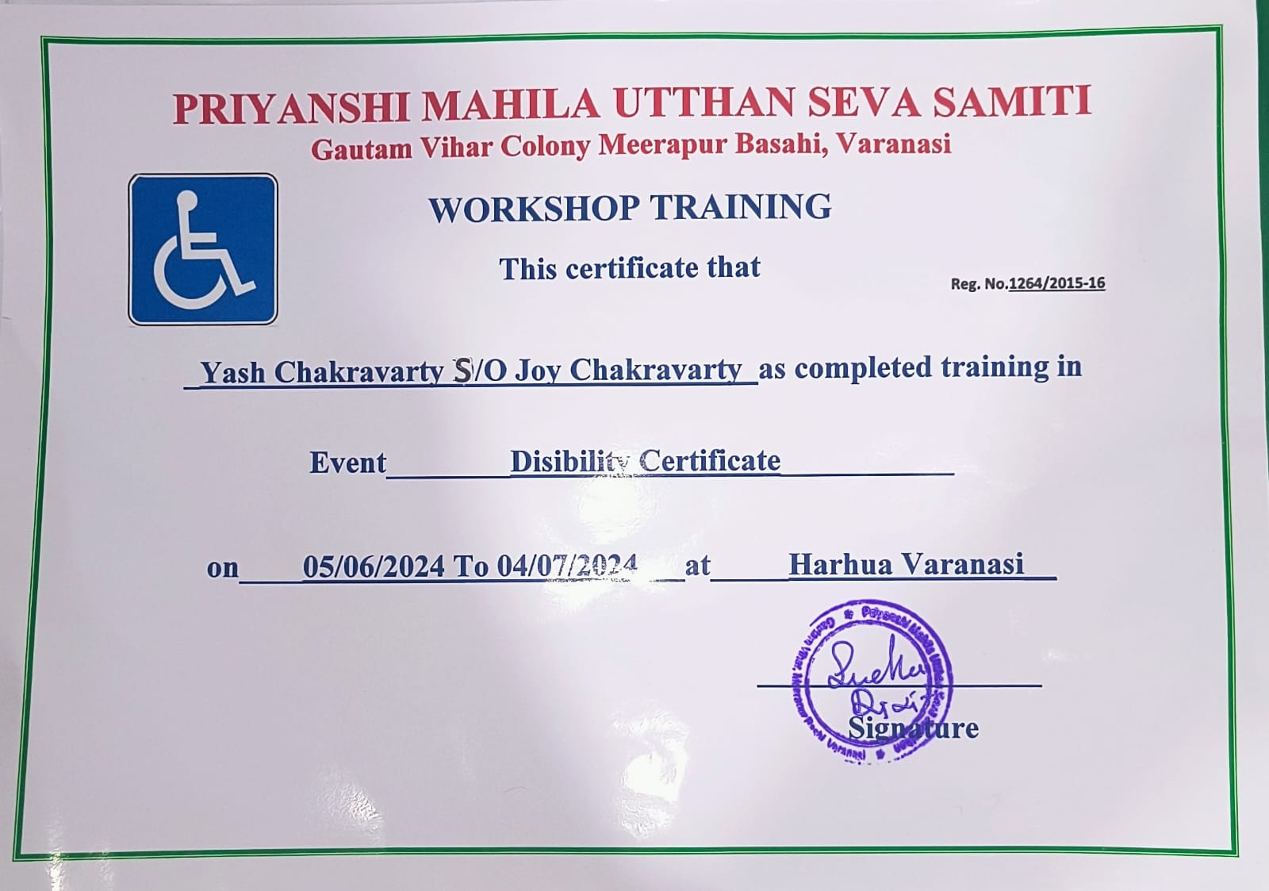

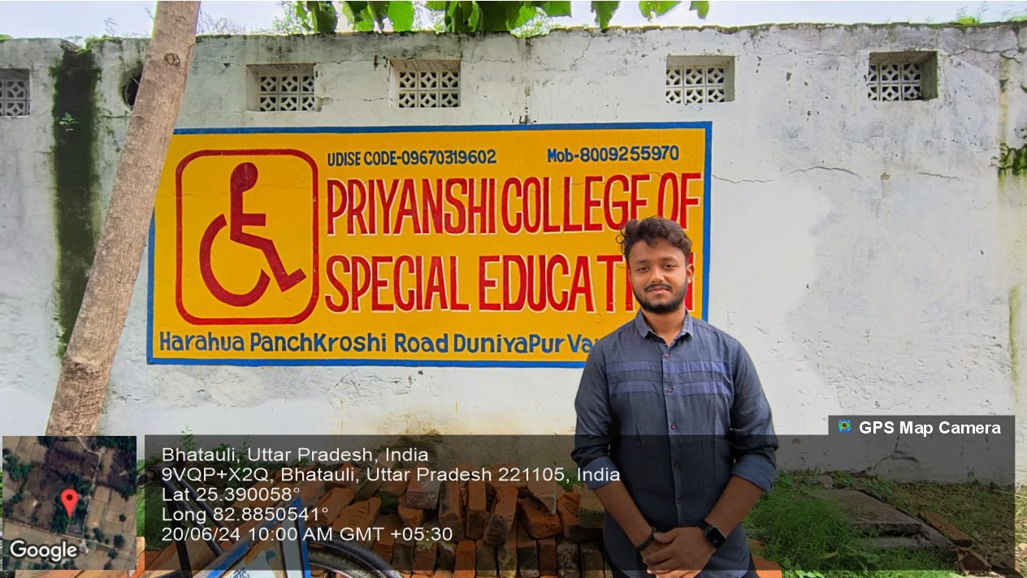

GEO TAG PICTURES

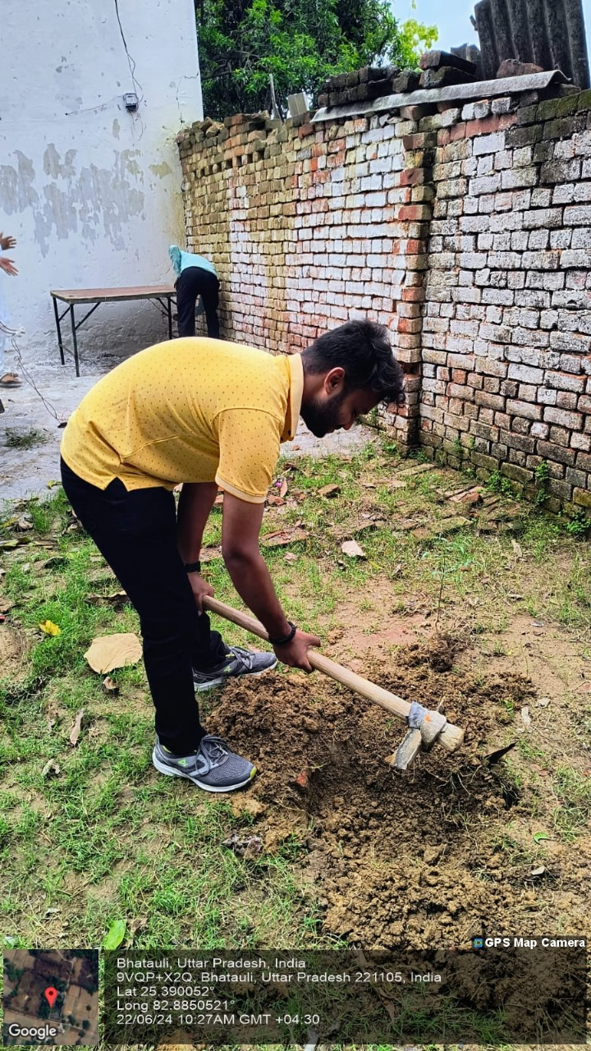

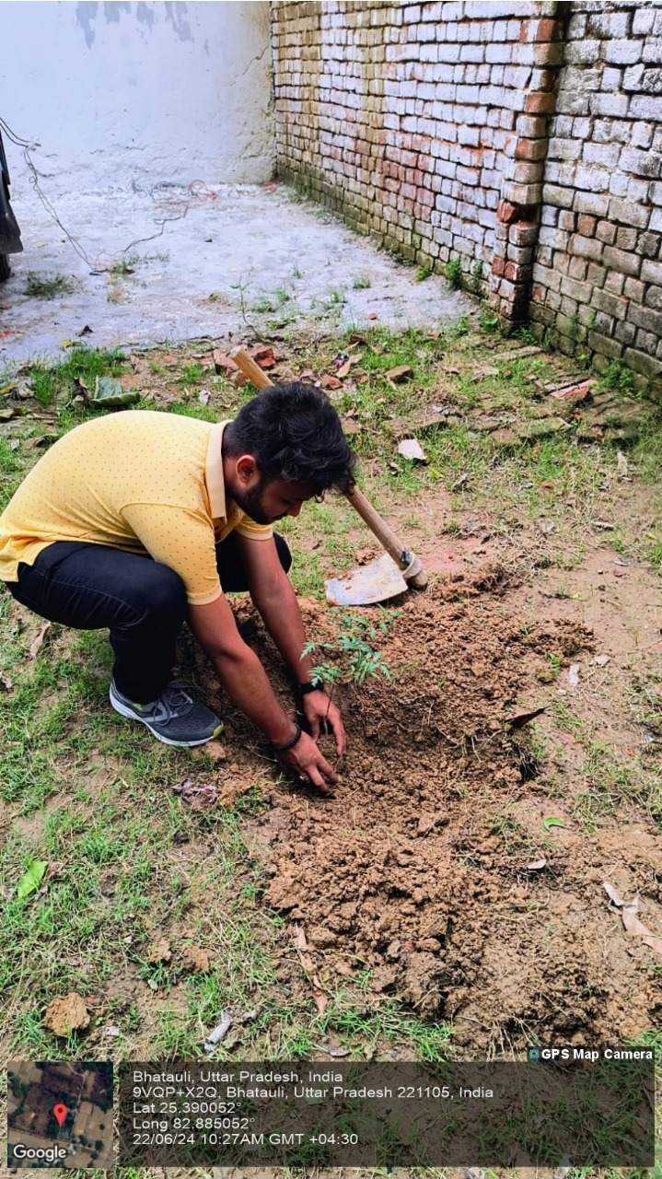

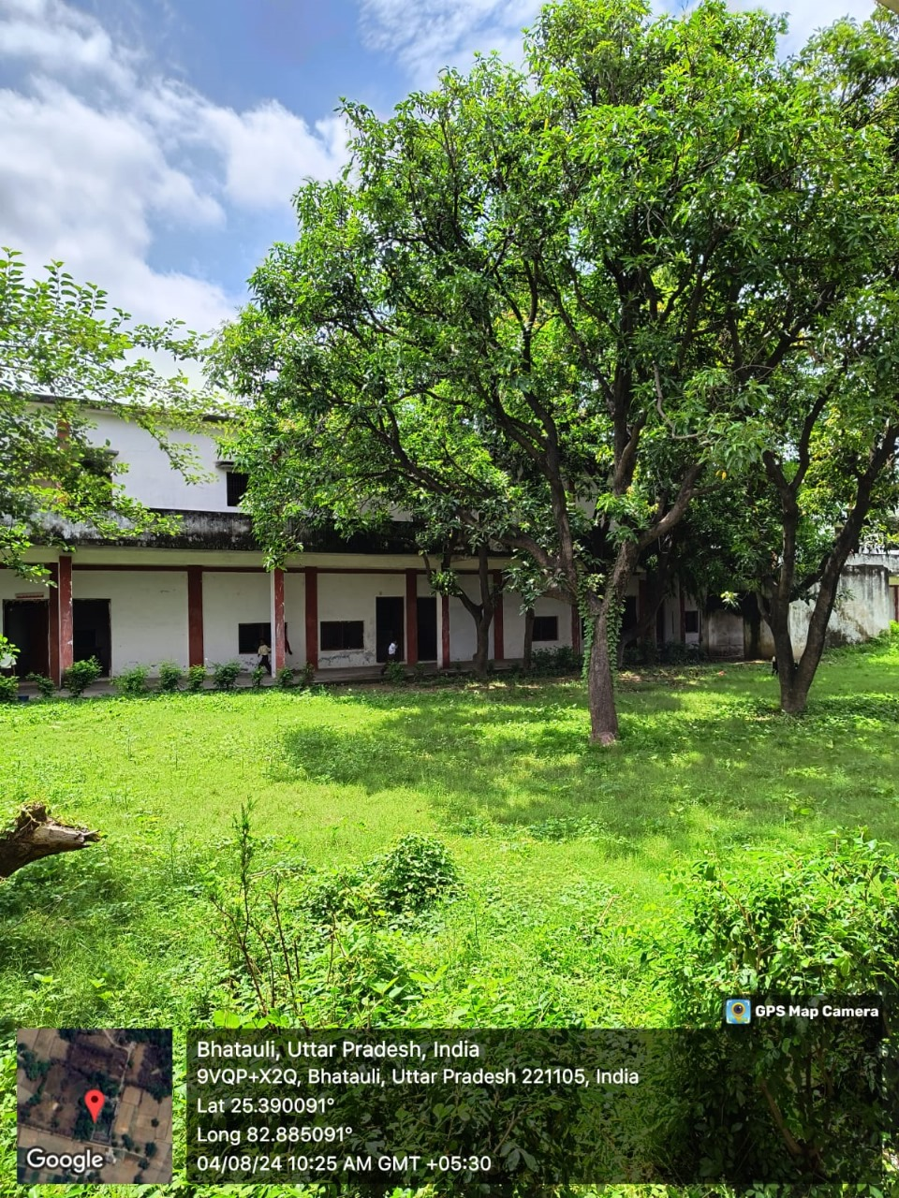

Planting trees at a school for mentally ill and disabled children fosters a nurturing environment, offering therapeutic benefits and a peaceful space for learning. This initiative not only beautifies the surroundings but also instills environmental awareness, responsibility, and a sense of connection with nature among the students.

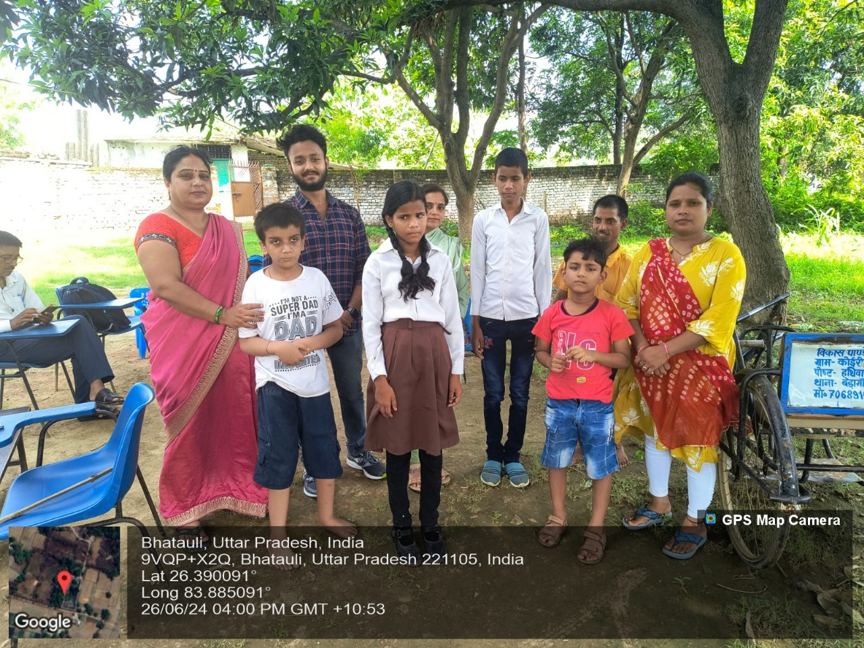

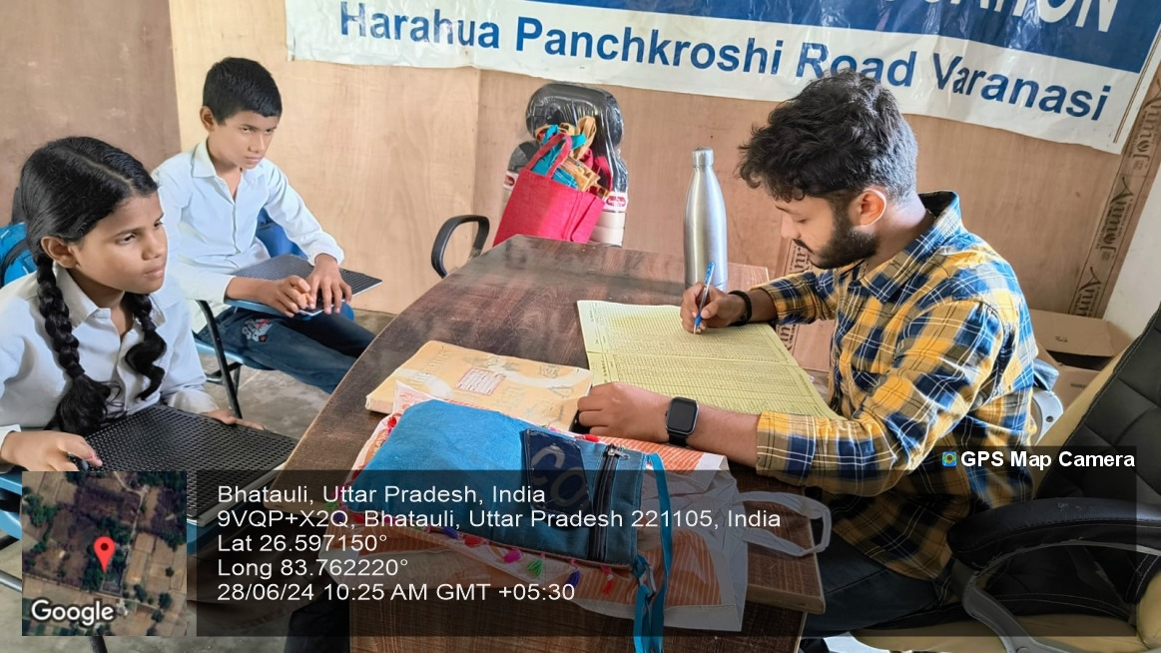

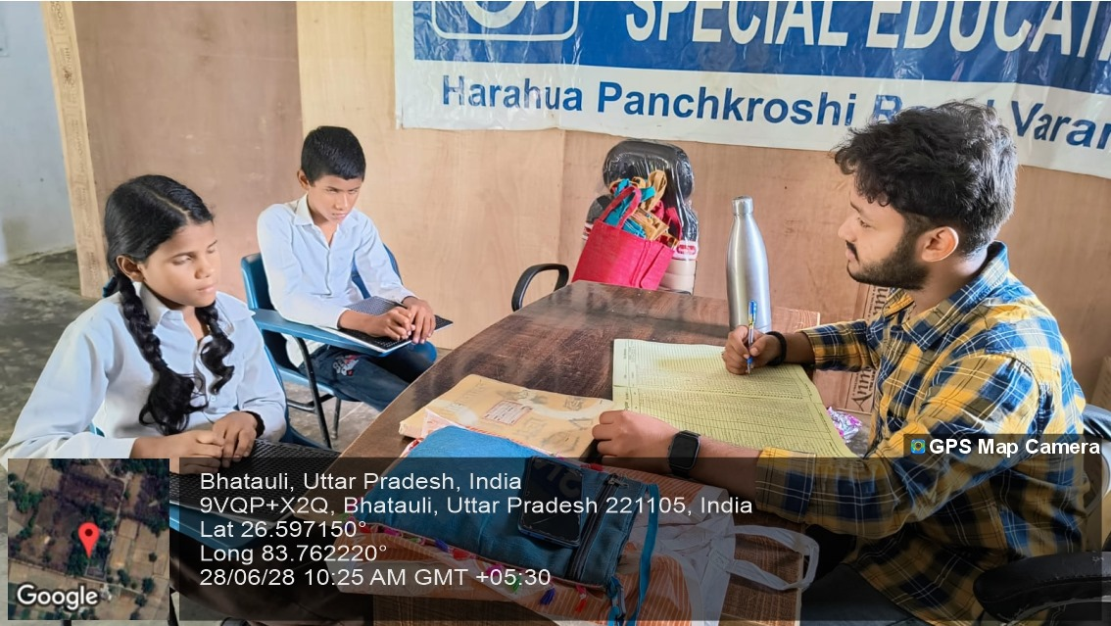

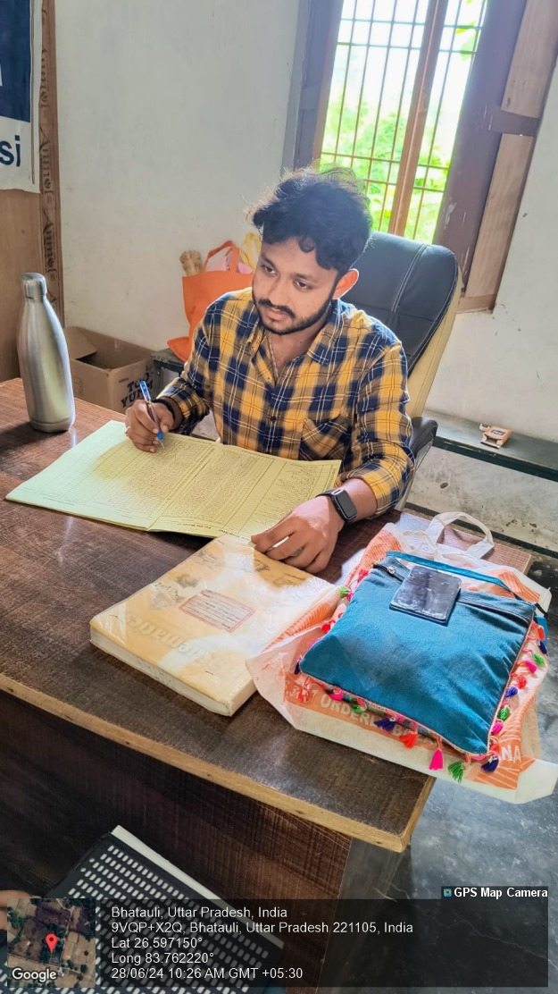

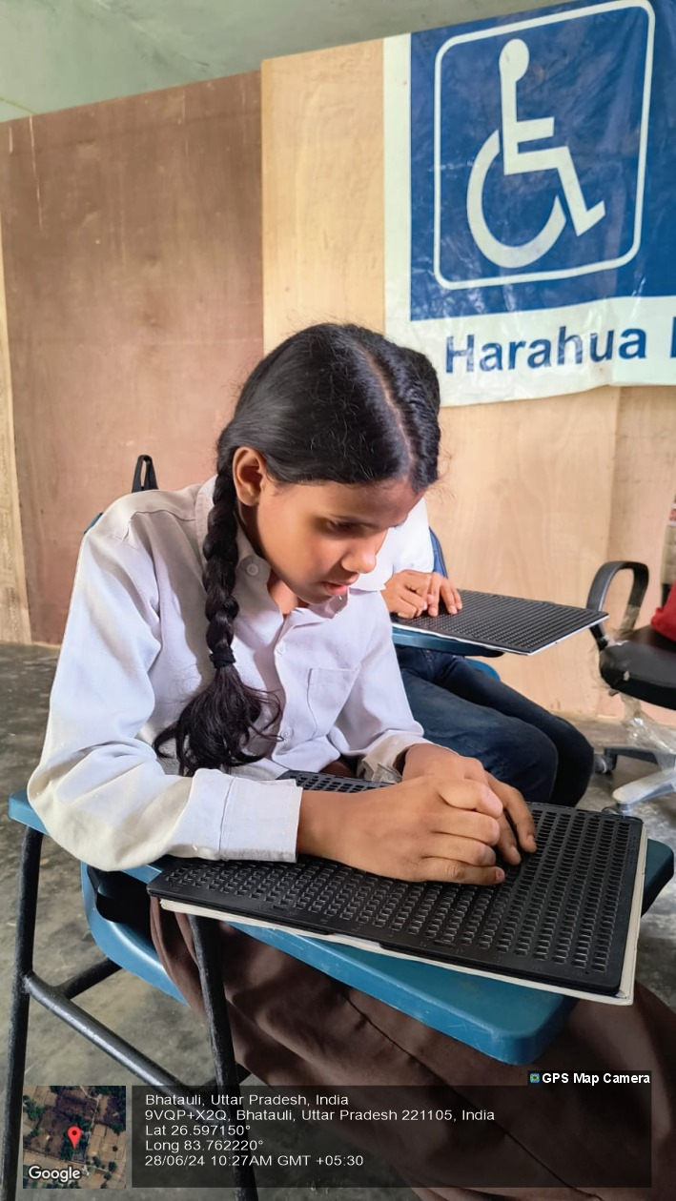

Teaching blind children involves using tactile resources, Braille, and auditory tools to create an inclusive learning environment. It focuses on engaging their other senses, fostering independence, and building confidence. This approach ensures that blind students can fully participate in education, developing essential skills and knowledge for their future.

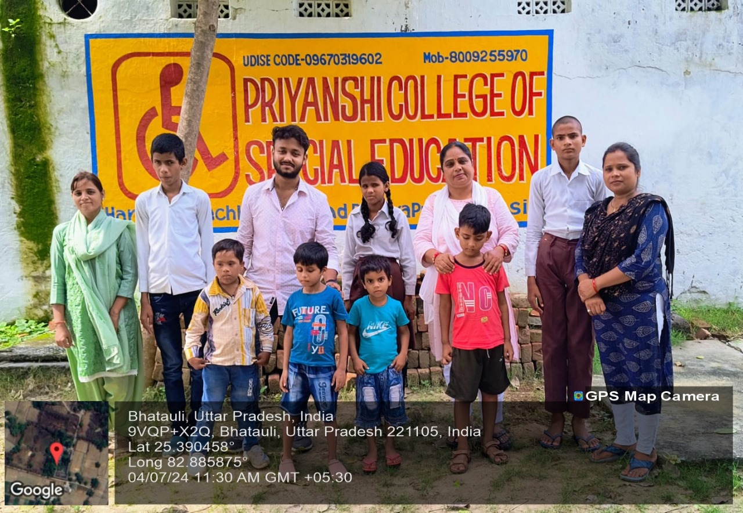

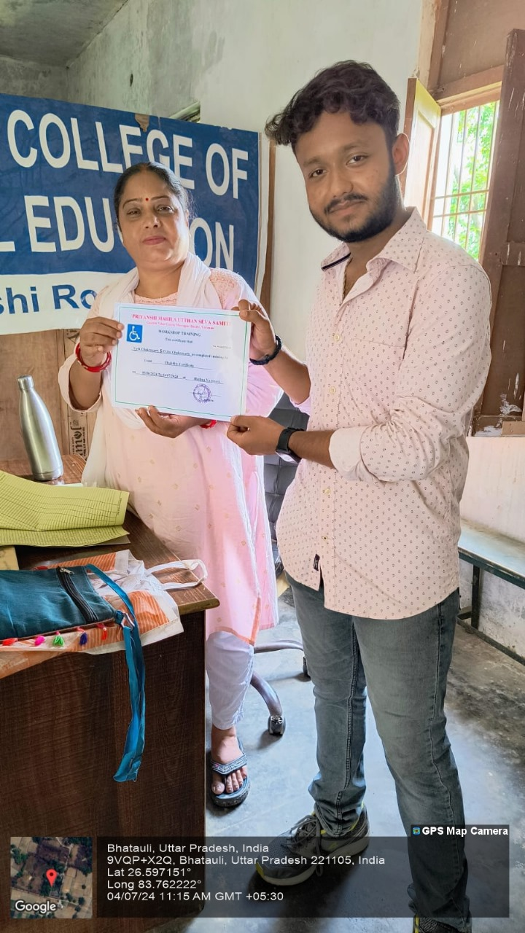

Article posted by the NGO

